Looking for an all-in-one proof of delivery app

KPoD is a cloud based app that digitally transforms your Proof of Delivery process by capturing customer comments, signature and images in real time. It helps drivers scheduling the delivery, get the optimized delivery route and use the app in offline mode in places where no or limited internet connectivity is available. The app empowers the back off team to get aware of the proof of delivery for a particular customer by digitally transferring the information to the backend applications.



**Real Time Electronic Proof of Delivery** – Your delivery team uses the mobile device to document each delivery and upload the data on cloud in real time

**Reduce Delivery Uncertainty** – with real time notifications, you and your customer can get delivery updates

**Capture Images and Text** – Your delivery team can upload time-date-location stamped photos and notes of each delivery. And of course, the app takes customer signatures

**Prevent False Damage Claims** – As your delivery team takes date time stamped images and signature of customer, this helps you to prevent any false damage claims

**QR Code Scanning to View Delivery Document** – search the relevant source delivery document (delivery note or invoice) by either scanning the paper document or search from backend application in real time

**Software For Businesses to Manage Deliveries**



## KPod Delivery Confirmation Electronic Signature Request

## 

**Intuitive User Interface with Offline Support**

## Focus More With Dark Theme

## Integration With Popular Apps

KPod has an easy, clear, intuitive interface and the ability to integrate and import data with any back office ERP or other line of business application. This makes it a lot easier to achieve end to end business integration and keep your relevant back office information up to date. Connect KPoD to thousands of popular apps.

Use logos of these apps

* Microsoft Dynamics 365 F&O
* Microsoft Dynamics Business Central
* SAP
* Oracle
* Sana Commerce
* WooCommerce
* Shopify
* QuickBooks

**Try KPoD Today Form**

Sample form below

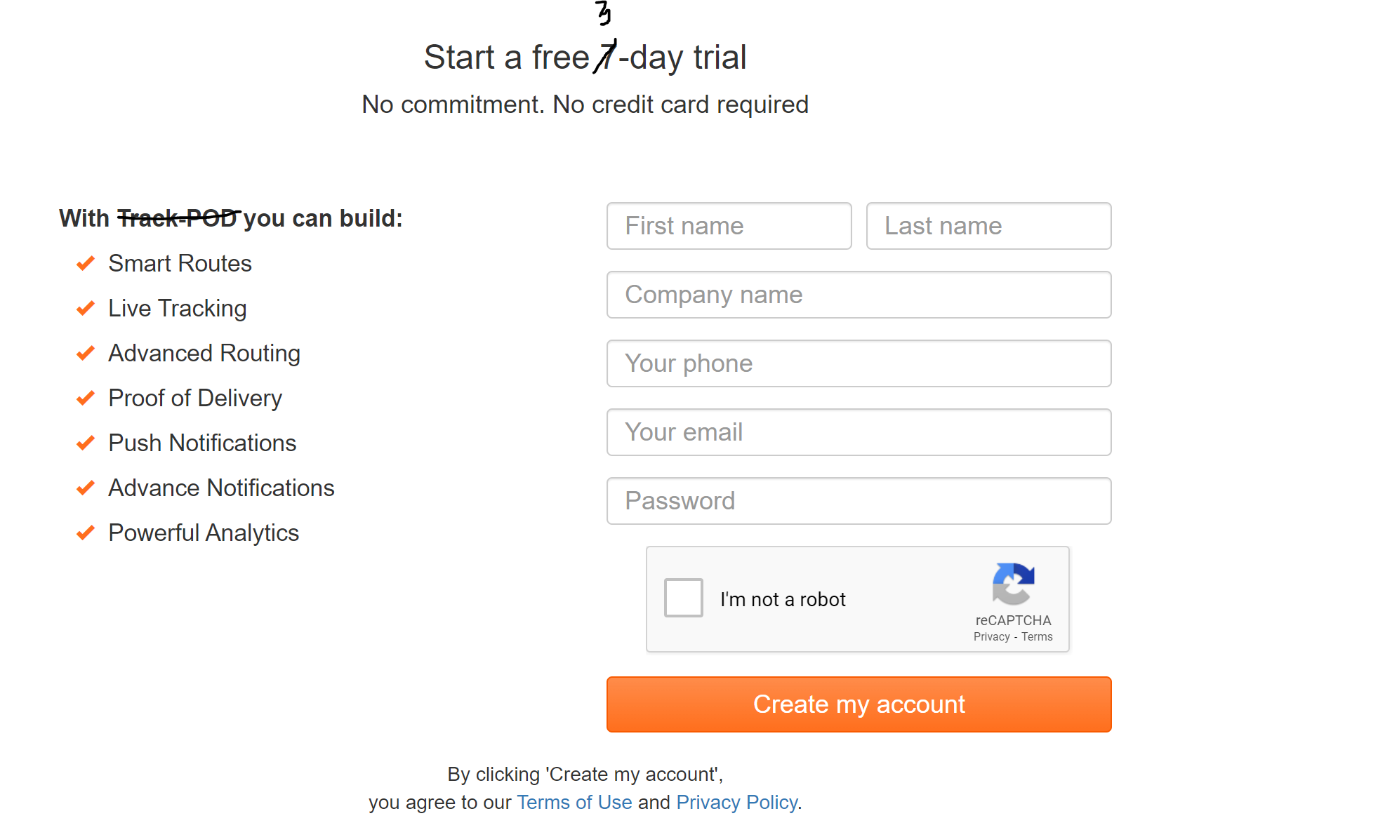

**With KPoD you can do:**

* Real Time Delivery Proof
* Capture Date Time Stamped Images and Signature
* Digitize the Delivery Process
* Online and Offline Usage
* Notifications

**Some fields will be required in the form**

**Book A Demo Form**

Sample form below

**Some fields will be required in the form**